Your job title: Executive Assistant
Where you will work: [Team Office Location]
Who’s the Boss: [Lead Agent’s Name]

Who are we?
Modify the following text to reflect your team’s value proposition] The mission of the [Team Name] team is to provide the premier customer service experience for each home seller and home buyer we work with. Knowledge we’ve gained through years of working in the local market empowers us to provide our home buyers and sellers with the advice they need to make informed decisions. Whether it’s selling a home, searching for a home, or negotiating a contract, each member of the [Team Name] team is an experienced real estate professional who applies their expert skills to each step of the process to help each client achieve an outstanding result.

Who are we looking for?
The Executive Assistant is an individual who is willing and able to earn the right to be an Assistant Executive. This person relishes the opportunity to build, implement, and manage multiple systems with minimal supervision. The Executive Assistant is deeply committed to completing tasks the right way with a high degree of quality, attention to detail, and consistent communication. This person has immense focus and can do one thing for a long time without getting distracted. This individual may exhibit some drive and desire to influence; however, the overriding marker of his/her behavior is persistence and stability.
An Executive Assistant is deeply committed to supporting the lead agent in achieving greater and greater levels of success, and to growing his/her own skills and developing into a supportive leader within the team. As the success of the team grows, this individual will be responsible for hiring, training, and leading additional team members to ensure all administrative tasks of the lead agent’s business continue to be completed to high standards with maximum efficiency.

[Modify this narrative as necessary to meet your team’s needs.]

What will you do?
These are the standards a well-above-average performer will maintain or exceed:
  - Build, implement, and manage all systems for sellers, buyers, lead generation, database management, information management, and back-office support
  - Responsible for all financial systems, including maintaining the books, paying the bills, handling payroll, assuring the collection of commissions, maintaining the budget, and generating financial reports
  - Oversee all contracts through closing
  - Create and maintain an operations manual that documents all systems and standards
  - Coordinate the purchase, installation, and maintenance of all office equipment
  - Be the first point of contact in handling customer inquiries or complaints
  - Keep the lead agent informed regarding any problems or issues that need to be handled
  - Responsible for hiring, training, consulting, and holding accountable all additional administrative team members

Essential duties and responsibilities
  - System development, implementation, and management
  - Information management
  - Oversight of contracts through closing
  - Customer/Vendor relations
  - Bookkeeping (A/R and A/P)

Communications/Interactions
  - Lead Agent – daily
  - Agent Team – daily
  - Administrative Team (as appropriate to team structure) – daily
  - Buyers/Sellers/Vendors – as appropriate

Management Responsibilities
  - As appropriate to team structure …) All administrative team members

Knowledge/Skills
  - Strong written and verbal communication skills
  - Exceptional organizational and project management abilities
  - Bookkeeping skills
  - Great ability to focus
  - Concerned about doing things the right way
  - Calm under pressure
  - Learning based
  - Service-based attitude
  - Proven ability to succeed
  - High school graduate
  - Bachelor’s degree preferred
  - Real estate license preferred
  - 1–3 years of service and management experience
  - 3–5 years of administrative experience

Compensation
Fill in as appropriate for your team/ organizational structure. Components to consider include base salary, health insurance, performance-based bonuses, Profit Share, and other employee benefits.

Team: Executive Assistant
The chart below describes the key talents and personality traits of a person matching the Team: Executive Assistant job at Keller Williams.
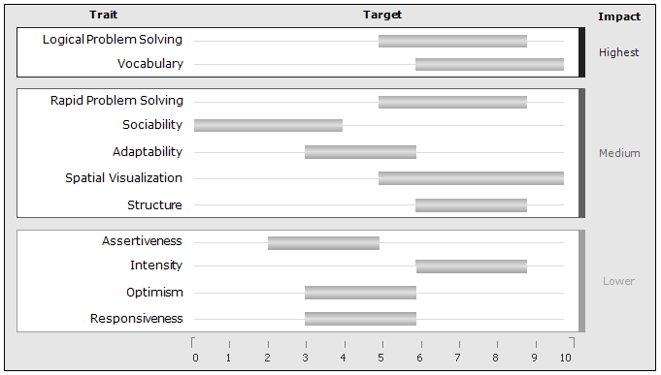
Traits appear in order of importance to the job. Gray bars indicate each trait's target range.
Traits without a gray bar are not predictive.

Highest Impact Traits
Logical Problem Solving: The target for this trait is medium high. People in this range have a good ability to solve complex problems logically. They are able to pull difficult issues apart to deal with the components one by one. They like being able to think through a problem or solution in order to present it carefully and logically to others.
Vocabulary: The target for this trait is high. People in this range learn easily and quickly from their environments. They pick up new information readily and learn rapidly when circumstances change. They typically make use of a wide range of acquired experience and knowledge in making decisions, deciding on a course of action, or adjusting to a changed environment.
Medium Impact Traits
Rapid Problem Solving: The target for this trait is medium high. People in this range can solve problems in rapid succession using a quick, intuitive approach. They like to have new issues to deal with every day. They can typically handle smaller issues quickly and move on to the next one without pausing.
Sociability: The target for this trait is low. People in this range are usually selective and purposeful in their communications. They prefer working with familiar people and developing relationships over time. They will be most productive working alone or in small, stable work groups. When working with others, they strongly prefer to engage in interactions with a work-related goal.
Adaptability: The target for this trait is medium. People in this range are concerned about doing what is correct according to accepted standards. They will typically be fair and consistent, but they will not compromise on important issues.
Spatial Visualization: The target for this trait is high. People in this range have a very strong ability to think in three or more dimensions. This helps them deal easily with structural or spatial tasks. This ability is strongly related to solving scientific, mathematical, design, and engineering problems. It also helps them deal with some kinds of abstractions, such as systems and complicated environments with many variables in constant flux.
Structure: The target for this trait is medium high. People in this range naturally focus on maintaining a structured environment and processing work in an organized manner. They are receptive to rules and regulations and to specific criteria for measuring success. While they prefer to avoid routine work and delays, they see the importance of carefully attending to crucial details.
Lowest Impact Traits
Assertiveness: The target for this trait is low medium. People in this range are naturally conservative in their actions. They prefer to think things through and to gauge potential outcomes before taking action. They are not typically demanding nor do they have the need to dominate other people or situations.
Intensity: The target for this trait is medium high. People in this range like to deal directly and energetically with obstacles at work. They feel a strong emotional drive to overcome difficulties and develop solutions when problems arise.
Optimism: The target for this trait is medium. People in this range are generally friendly and have a positive attitude toward others. They tend to take people and situations at face value unless there is some reason to be skeptical.
Responsiveness: The target for this trait is medium. People in this range are appropriately responsive and open with others but not impetuous or easily excitable. They like to stay focused on their primary objectives without being excessively rushed or unduly sidetracked by less important factors.

