**Your job title: *Buyer Agent***

**Where you will work: [*Team Office Location*]**

**Who’s the Boss: [*Direct Manager’s Name*]**

**Who are we?**

Modify the following text to reflect your team’s value proposition] *The mission of the [Team Name] team is to provide the premier customer service experience for each home seller and home buyer we work with. Knowledge we’ve gained through years of working in the local market empowers us to provide our home buyers and sellers with the advice they need to make informed decisions. Whether it’s selling a home, searching for a home, or negotiating a contract, each member of the [Team Name] team is an experienced real estate professional who applies their expert skills to each step of the process to help each client achieve an outstanding result.*

**Who are we looking for?**

The Buyer Agent is an individual who is highly sociable, draws energy from working with people, and is optimistic and outgoing. They have a strong sense of urgency, but not at the expense of quality. In addition, he/she demonstrates on a daily basis the knowledge, attitudes, skills, and habits of a high-achieving buyer agent who is committed to putting clients first, to doing the right thing, and to seeking win-win agreements. The Buyer Agent prospects for leads daily, closes those leads to appointments, closes for agreements, and then conducts a high-level fiduciary needs analysis. At that point, he/she communicates the desired criteria to the Showing Assistant. The Showing Assistant will select homes that meet the criteria and will drive the clients to the homes. That person will refine the criteria and close for contract offers. At that point, the Buyer Agent will negotiate the offer, write the contract, and oversee the deal through its close.

The Buyer Agent also demonstrates a commitment to learning and strives for growth by regularly attending courses, teaching courses when appropriate, and regularly practicing scripts and dialogues. He/She is committed to investing in the people on the team and regularly provides them with learning and growth opportunities as well.

[*Modify this narrative as necessary to meet your team’s needs*.]

**What will you do?***These are the standards a well-above-average performer will maintain or exceed:*

* + Prospect for buyer leads, convert leads to appointments, close for agreements, and conduct high-level fiduciary needs analyses
  + Oversee Showing Assistant in selecting homes that meet clients’ needs, identifying homes that best meet those needs, refining needs, and closing to contract offers
  + Consult with clients to ensure fiduciary service of the real estate transaction from initial contact through contract to close
  + Effectively negotiate, or oversee negotiations, for all buyers
  + Develop expert knowledge regarding mortgage financing, neighborhoods, schools, and all homeownership issues

**Essential duties and responsibilities**

* + Oversee all aspects of buyers’ transactions from initial contact to contract to close
  + Hire, train, and consult all Buyer Agents and Showing Assistants
  + Negotiating for buyers

**Communications/Interactions**

* + Lead Agent – daily
  + Agent Team – daily
  + Buyers/Sellers/Vendors – daily

**Management Responsibilities**

* + Showing Assistants

**Knowledge/Skills**

* + Excellent at building rapport
  + People oriented
  + Strong written and verbal communication skills
  + Good organizational skills
  + Learning based
  + Able to build and lead a team
  + Willing to learn scripts and dialogues
  + High school graduate
  + Real estate license
  + 1–3 years of industry and sales experience preferred
  + 1–3 years of management experience preferred

**Compensation**

*Fill in as appropriate for your team/ organizational structure. Components to consider include base salary, health insurance, performance-based bonuses, Profit Share, and other employee benefits*.

|  |  |  |
| --- | --- | --- |
| **Team: Buyer Agent** |  |  |

The chart below describes the key talents and personality traits of a person matching the Team: Buyer Agent job at Keller Williams.

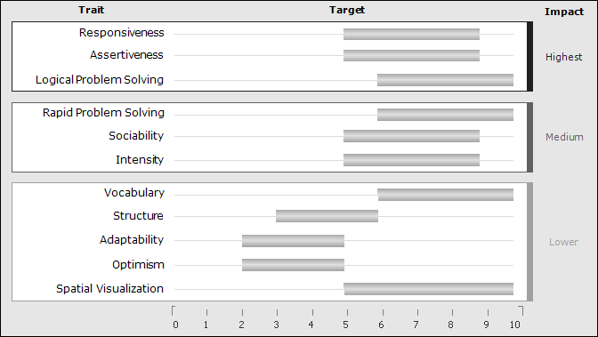

*Traits appear in order of importance to the job. Gray bars indicate each trait's target range.*

*Traits without a gray bar are not predictive.*

**Highest Impact Traits**

**Responsiveness**  The target for this trait is medium high. People in this range are responsive and quick in their reactions. They are naturally fast-moving and action-oriented, and they tend to operate with a sense of urgency. They tend to be dissatisfied with slow-moving environments.

**Assertiveness**  The target for this trait is medium high. People in this range are assertive and results-driven individuals who enjoy taking action. They are decisive and competitive, and they prefer a direct approach to getting things done.

**Logical Problem Solving**  The target for this trait is high. People in this range have a very strong ability to develop logical solutions to complex problems. They are adept at using a linear, step-by-step approach to break larger problems down into smaller components. They are generally able to explain their solutions carefully and clearly to others.

**Medium Impact Traits**

**Rapid Problem Solving**  The target for this trait is high. People in this range can solve many problems in rapid succession using a quick, intuitive approach. They usually like to have many new issues to deal with every day. They can typically handle smaller issues quickly and move on to the next one without pausing.

**Sociability**  The target for this trait is medium high. People in this range display a good level of natural sociability. Characteristically, they take a genuine interest in other people and in meeting their legitimate needs. They have good capacity for communicating effectively and for keeping people informed.

**Intensity**  The target for this trait is medium high. People in this range like to deal directly and energetically with obstacles at work. They feel a strong emotional drive to overcome difficulties and develop solutions when problems arise.

**Lowest Impact Traits**

**Vocabulary**  The target for this trait is high. People in this range learn easily and quickly from their environments. They pick up new information readily and learn rapidly when circumstances change. They typically make use of a wide range of acquired experience and knowledge in making decisions, deciding on a course of action, or adjusting to a changed environment as needed.

**Structure**  The target for this trait is medium. People in this range are most productive in jobs that provide a moderate level of structure. However, they are not dependent on step-by-step direction and prefer to have some latitude and flexibility in developing work strategies.

**Adaptability**  The target for this trait is low medium. People in this range will respect and respond to other people's legitimate expectations while maintaining their own emotional independence. They will not usually compromise just to avoid conflict.

**Optimism**  The target for this trait is low medium. Although people in this range can be generally friendly, they tend to maintain a healthy skepticism about people and situations and anticipate things that might possibly go wrong.

**Spatial Visualization**  The target for this trait is high. People in this range are able to think about and visualize complex systems. They are able to deal with problems in which there are multiple variables that are constantly changing. They can create mathematical models of problems in order to get to solutions. They can mentally manipulate variables in complex models to understand what will happen when something changes.