Your job title: Listing Agent
Where you will work: [Team Office Location]
Who’s the Boss: [Lead Agent’s Name]

Who are we?
Modify the following text to reflect your team’s value proposition] The mission of the [Team Name] team is to provide the premier customer service experience for each home seller and home buyer we work with. Knowledge we’ve gained through years of working in the local market empowers us to provide our home buyers and sellers with the advice they need to make informed decisions. Whether it’s selling a home, searching for a home, or negotiating a contract, each member of the [Team Name] team is an experienced real estate professional who applies their expert skills to each step of the process to help each client achieve an outstanding result.

Who are we looking for?
The Listing Agent is an individual who thrives on taking risks and facing challenges while maintaining a win-win, positive attitude. In addition, he/she demonstrates on a daily basis the knowledge, attitudes, skills, and habits of a high-achieving listing agent who is committed to putting clients first, doing the right thing, and seeking win-win agreements. The Listing Agent prospects for seller leads daily (includes identifying and calling for sale by owner and expired listing candidates), closes those leads to appointments, closes appointments to agreements, and then provides high-level fiduciary advice on pricing strategy and staging the home for sale. He/She will market the home or work in tandem with a Listing Assistant to launch a marketing campaign. He/She will evaluate showing feedback and reevaluate pricing as needed. Upon receiving an offer, the Listing Agent will negotiate the offer, write the contract, and oversee the deal through its close.

The Listing Agent also demonstrates a commitment to learning and strives for growth by regularly attending courses, teaching when appropriate, and regularly practicing scripts and dialogues. He/She is committed to investing in team members and regularly provides them with learning and growth opportunities as well.

[Modify this narrative as necessary to meet your team’s needs.]

What will you do?
These are the standards a well-above-average performer will maintain or exceed:
  - Prospect for seller leads, convert leads to appointments, and close appointments to agreements
  - Provide high-level fiduciary advice on pricing strategies and staging homes for sale
  - Market the home as appropriate
  - Responsible for identifying, contacting, and obtaining appointments with for sale by owners and expireds, as well as maintaining consistent lead follow-up until the prospect lists or decides not to sell
  - Evaluate showing feedback and reevaluate pricing as needed
  - Effectively negotiate, or oversee negotiations for sellers
Consult with clients to ensure fiduciary service of the real estate transaction from initial contact through contract to close

Essential duties and responsibilities
  - Oversee all aspects of sellers’ transactions from initial contact to contract to close
  - Hire, train, and consult all Listing Agents and Listings Assistants
  - Negotiate for sellers

Communications/Interactions
  - Listing Manager – daily
  - Sellers – daily
  - Transaction Coordinator – daily

Management Responsibilities
  - Listing Assistants

Knowledge/Skills
  - Strong written and verbal communication skills
  - Excellent organizational and time-management abilities
  - Calm under pressure
  - Computer skills
  - High school graduate
  - Real estate license
  - 1–3 years of industry and sales experience

Compensation
Fill in as appropriate for your team /organizational structure. Consider base salary, health insurance, performance-based bonuses, Profit Share, and other employee benefits.

Team: Listing Agent
The chart below describes the key talents and personality traits of a person matching the Team: Listing Agent job at Keller Williams.
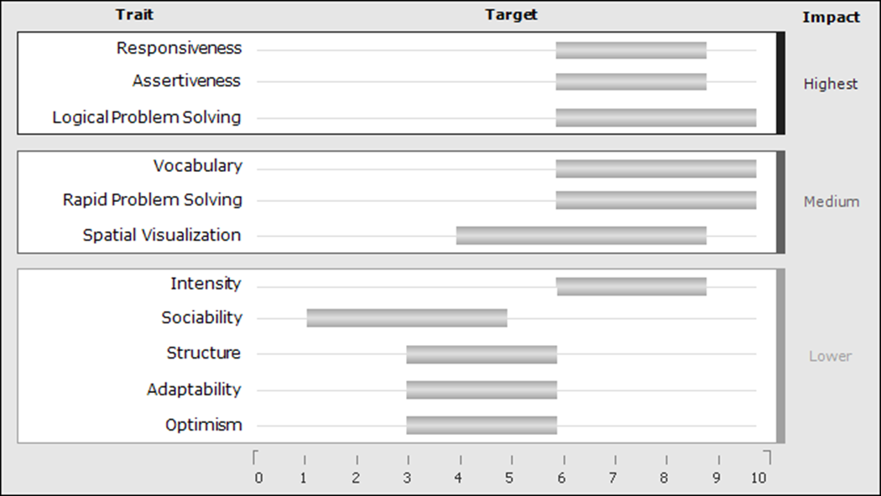
Traits appear in order of importance to the job. Gray bars indicate each trait's target range.
Traits without a gray bar are not predictive.

Highest Impact Traits
Responsiveness The target for this trait is medium high. People in this range are responsive and quick in their reactions. They are naturally fast-moving and action-oriented, and they tend to operate with a sense of urgency. They tend to be dissatisfied with slow-moving environments.
Assertiveness The target for this trait is medium high. People in this range are assertive and results-driven individuals who enjoy taking action. They are decisive and competitive, and they prefer a direct approach to getting things done.
Logical Problem Solving The target for this trait is high. People in this range have a very strong ability to develop logical solutions to complex problems. They are adept at using a linear, step-by-step approach to break larger problems down into smaller components. They are generally able to explain their solutions carefully and clearly to others.

Medium Impact Traits
Vocabulary The target for this trait is high. People in this range learn easily and quickly from their environments. They pick up new information readily and learn rapidly when circumstances change. They typically make use of a wide range of acquired experience and knowledge in making decisions, deciding on a course of action or adjusting to a changed environment as needed.
Rapid Problem Solving The target for this trait is high. People in this range can solve many problems in rapid succession using a quick, intuitive approach. They usually like to have many new issues to deal with every day. They can typically handle smaller issues quickly and move on to the next one without pausing.
Spatial Visualization The target for this trait is medium high. People in this range can engage in a variety of tasks, including financial, technical, mechanical, mathematical, and engineering tasks. They can visualize structures and complex systems. They can think about problems in which there are multiple variables that are changing. They are also able to use technology solutions to solve problems.
Lowest Impact Traits
Intensity The target for this trait is medium high. People in this range like to deal directly and energetically with obstacles at work. They feel a strong emotional drive to overcome difficulties and develop solutions when problems arise.
Sociability The target for this trait is low medium. People in this range are reserved and conservative on a social basis. They tend to be low-key rather than outgoing or spontaneous, but they can enjoy friendly exchanges with others. They are willing to approach new people for a specific purpose or to accomplish a concrete goal.
Structure The target for this trait is medium. People in this range are most productive in jobs that provide a moderate level of structure. However, they are not dependent on step-by-step direction and prefer to have some latitude and flexibility in developing work strategies.
Adaptability The target for this trait is medium. People in this range are concerned about doing what is correct according to accepted standards. They will typically be fair and consistent, but they will not compromise on important issues.
Optimism The target for this trait is medium. People in this range are generally friendly and have a positive attitude toward others. They tend to take people and situations at face value unless there is some reason to be skeptical.

